
PiiE Documentation Procedures Manual
October 2005
Release 1.0

PiiE-DPM-05-01000

PiiE Document Procedures Manual
October 2005
Release 1.0

PiiE-DPM-05-0100
Disclaimer
Digital Harbor International, Inc. makes no representations or warranties with respect to the contents or use of this manual, and specifically disclaims any express or implied warranties of merchantability or fitness for any particular purpose. Digital Harbor, Inc. reserves the right to revise this publication and to make changes to its content, at any time, without obligation to notify any person or entity of such revisions or changes.
Digital Harbor International, Inc. makes no representations or warranties with respect to any Digital Harbor software, and specifically disclaims any express or implied warranties of merchantability or fitness for any particular purpose. There are no warranties that extend beyond the descriptions contained in these paragraphs. No warranty may be created or extended by sales representatives or written sales materials. Digital Harbor, Inc. reserves the right to make changes to any and all parts of Digital Harbor software, at any time, without any obligation to notify any person or entity of such changes. Digital Harbor, Inc. shall not be liable for any loss of profit or any other commercial damages, including but not limited to special, incidental, consequential, or other damages.

Copyright © 2002-2005, Digital Harbor, Inc. All rights reserved. No part of this publication, including its interior design and icons, may be reproduced, stored in a retrieval system, or transmitted in any form by any means, electronic, mechanical, photocopying, recording, or otherwise, without written permission of Digital Harbor.
Contents
Trademarks vii
Preface ix
Purpose of this Guide ix
Who Should Use This Guide? ix
What is in This Guide? ix
What's New ix
Document Conventions ix
Related Documentation x
PiiE xi
PiiE Fusion Server xi
PiiE Smart Client xi
On-Line Help xii
Contact Us xii
Customer Support xii
Technical Documentation xii
About this Manual 1
RoboHelp Projects 3
Creating a New RoboHelp Project 3
Exploring the RoboHelp Project Template 3
Documentation Conventions 7
Menus 9
Dialog Boxes 9
Code Formatting 11
Enterprise Designer Naming Conventions 11
Fusion Administrator Console Naming Conventions 12
Smart Client Administrator Console Naming Conventions 13
Smart Client Builder Naming Conventions 15
Additional Conventions 16
Topic Length 16
Chapter Length 16
Images 17
Online Help 19
Creating an Online Help Layout 19
Generating Online Help 21
Preparing a Printed Document 23
Creating a Printed Document Layout 23
Generating a Printed Document 27
Cleaning Up a Word Document 27
First Pass 28
Second Pass 30
Third Pass 31
Fourth Pass 32
Preparing a PDF 35
Installing Acrobat Templates and Add-Ins 35
Configuring Acrobat Conversion Settings 36
Creating a PDF 41
Cleaning up a PDF 42
Removing Unnecessary Functionality 42
Adjusting Bookmark Mapping 43
Editing Bookmarks 43
Checking a Document into CVS 45
Checking a New Document into CVS 45
Checking an Existing Document into CVS 46
Appendix A 49
Style Templates 49
Heading Styles 49
Paragraph Styles 49
Table Styles 50
Font Styles 51
Table Templates 52
Step-Action Tables 52
Code Example Table 52
Output Table 52
Note Templates 53

Trademarks
PiiE®, Digital Harbor®, and the Digital Harbor logo are registered trademarks of Digital Harbor, Inc.
Copyright © 2002-2005, Digital Harbor, Inc. All rights reserved. No part of this publication, including its interior design and icons, may be reproduced, stored in a retrieval system, or transmitted in any form by any means, electronic, mechanical, photocopying, recording, or otherwise, without written permission of Digital Harbor.
Microsoft, Microsoft Internet Explorer, Windows and Windows NT are registered trademarks or trademarks of Microsoft Corp. in the United States and/or other countries.
UNIX is a registered trademark in the United States and other countries, exclusively licensed through X/Open Company, Ltd.
Sun, Sun Microsystems, the Sun Logo, Solaris, SPARC, Java, and all Java-based trademarks and logos are trademarks or registered trademarks of Sun Microsystems, Inc., in the United States and other countries.
All SPARC trademarks are used under license and are trademarks or registered trademarks of SPARC International, Inc. in the United States and other countries. Products bearing SPARC trademarks are based upon an architecture developed by Sun Microsystems, Inc.
Netscape, Netscape Navigator, and Netscape Communicator are registered trademarks and service marks of Netscape Communications Corporation in the United States and other countries. The Netscape logo and Netscape product and service names are also trademarks and service marks of Netscape Communications Corporation, which may be registered in other countries.
Apple, Apple Computer, and QuickTime are registered trademarks of Apple Computer.
WebLogic and BEA are registered trademarks of BEA Systems, Inc.
JBoss and JBoss Group are the registered trademark and servicemark of Marc Fleury under operation by The JBoss Group, LLC.
SQL Server is a registered trademark of Microsoft Corp.
Oracle, Oracle9, Oracle10, the Oracle Logo and all Oracle trademarks and logos are trademarks or registered trademarks of Oracle, Inc., in the United States and other countries.
Sybase is a registered trademark of Sybase Inc.
DB2 is a registered trademark of International Business Machines.
JSQLConnect is a registered trademark of JNetDirect in the United States and other countries.
Rational and Rational Rose are trademarks or registered trademarks of Rational Software Corporation in the United States and other countries.
ERwin and AllFusion ERwin Data Modeler are trademarks or registered trademarks of Computer Associates.
SAP, R/3, mySAP, mySAP.com, xApps, xApp, SAP NetWeaver and other SAP products and services mentioned herein as well as their respective logos are trademarks or registered trademarks of SAP AG in Germany and other countries.
ArcGIS, ArcIMS, ArcSDE, ESRI, GIS by ESRI, GISData Server, MapObjects, SDE, SML, Spatial Database Engine, the MapObjects logo, and www.esri.com are trademarks, registered trademarks, or service marks of ESRI in the United States, the European Community, or certain other jurisdictions.
JadeLiquid and WebRenderer are trademarks of JadeLiquid Software in the United States and other countries.
SonicMQ is a registered trademark of Sonic Software, Inc.
Eclipse is a registered trademark of the Eclipse Foundation.
JBuilder is a registered trademark of Borland, Inc.
Intel is a trademark or registered trademark of Intel Corporation or its subsidiaries in the United States and other countries.
Portions of this product were created using RoboHelp. Copyright © 1997-2002 eHelp™ Blue Sky, and RoboHelp are trademarks or registered trademarks of the eHelp corporation in the United States and other countries.
Portions of this product created using Infragistics. Copyright © 2003 Infragistics, Inc.
Portions of this product created using JClass. JClass and the JClass Logo are trademarks or registered trademarks of Sitraka, Inc. in the United States and other countries.
Other product and company names mentioned in this document may be the trademarks or registered trademarks of their respective owners.

Preface

Purpose of this Guide
This manual is intended to provide Digital Harbor’s technical documentation staff with a common set of standards and procedures to be followed when creating new or editing existing technical documentation.

Who Should Use This Guide?
This manual in intended for Digital Harbor’s technical writers. It assumes the reader has good working knowledge of RoboHelp HTML, Microsoft Word, and Adobe Acrobat and Distiller.

What is in This Guide?
This manual provides information that will allow the reader to
- create a new RoboHelp project
- generate online help
- generate printed documentation
- manage end-user products

What's New
This is a new document.

Document Conventions
Convention | Description
<value> | Opening and closing angle brackets are used to indicate a variable. The value displayed can depend on your system and installation, or on your naming conventions.  Example: Smart Client <version>
<key1>+  <key2> | Press and hold <key1> and then press <key2>.  Example: Ctrl+Tab
Press | Used to indicate that you must press a key or keys on your keyboard.  Example: Press K.
Click or Double-click | Indicates you must click or double-click the mouse. Double-clicking means clicking the mouse button twice in rapid succession. Unless otherwise stated, click or double-click implies clicking the left mouse button.  Example: Click OK.
Drag or  Drag and drop | Drag operations include moving, copying, or linking selected objects. You do this by clicking an object to select it, and while still holding down the mouse button, dragging the mouse pointer from one location to another, until you release the mouse button where you want the selected object to go.  Example: Drag the Calendar component to the canvas.
Highlight | Select some object or text using the mouse. The area becomes enclosed in a dark bar.  Example: Highlight the word “tool”.
Step-Action Procedures | This guide uses step-action procedures:
  1 | When you perform this action...  Result: You get this result.
  2 | When you perform this subsequent action...  Result: You get this result.
 | Notes are designated by a Note icon. Notes emphasize or supplement important points. Notes may also contain information that applies only in special cases.
 | Tips are designated by a Tip icon. Tips provide techniques, procedures, or shortcuts that you can apply to your specific situation.
 | Warnings are designated by a Warning icon. Warnings advise you to take or to avoid specific actions that could result in data loss.

Related Documentation
PiiE provides an extensive set of printed documentation in PDF format. You can find this documentation on your installation CD in the Documents folder. You can also access these documents from the main installation screen by clicking the desired product's Documentation button.

PiiE
- PiiE System Administrator Guide, PSF-SAG-05-0100
This guide describes Enterprise Designer, Fusion Server and Smart Client administration tasks. Consult this guide if you are a PiiE administrator and want to learn how to install and configure PiiE packages, manage Fusion Server or Smart Client Broker, deploy a model, establish security and manage user accounts.

PiiE Fusion Server
- Enterprise Designer User Guide, PSF-EDUG-05-0700
This manual describes how to build the models deployed to PiiE Fusion Server. This document covers entities, attributes, relationships, processes, events, rules, business logic, EIS integration, and mapping to data sources and XML schemas.
- Software Development Kit, PSF-SDK-05-0400
This document is intended for experienced Java developers who are tasked with extending PiiE Fusion Server's functionality. An extensive set of programming examples demonstrate how to create persistent business objects, define and execute queries, create and manage processes, develop and deploy custom transformations and methods, develop JMS message handlers, and design work agents.

PiiE Smart Client
- Builder User Guide, PSC-BUG-05-0700
Builder has advanced features for creating and publishing composite applications and reports. Consult this guide if you are an experienced PiiE author and want to learn about data binding, forms, variables, conditions, Web Services, PiiE Fusion Server integration, and scripting.
- Communicator User Guide, PSC-CUG-05-0500
Communicator provides authors with a usable interface for creating, publishing, and working with reports. Communicator provides a subset of the features available with Builder.
- Component Reference Guide, PSC-CRG-05-0500
This manual describes all PiiE components and their properties, events, and behaviors. This document is intended for all users interested in learning more about PiiE components.
- Scripting User Guide, PSC-SG-05-0300
This manual provides detailed information about how to write scripts and how to integrate them into your composite applications. Example scripts demonstrate how to interact with the user, access and change component properties, create and trigger events, create and execute behaviors, and create and modify complex Fusion behaviors at runtime.
- Software Development Kit, PSC-SDK-05-0300
This guide describes PiiE's Smart Client architecture and discusses how to build and add custom components and modules. Programming examples illustrate how to wrap components, define properties, add behaviors and events, provide menus, and manage data binding. This document is intended for third-party developers.

On-Line Help
All of PiiE's UI-based products provide easy-to-use indexed and searchable online help that enables you to quickly locate relevant information. Online help is accessible for the following products.
- PiiE Smart Client Administrator Console
- PiiE Fusion Server Administrator Console
- Enterprise Designer
- PiiE Smart Client Builder (includes information presented in the PiiE Smart Client Builder User Guide, PiiE Smart Client Component Reference Guide, and PiiE Smart Client Scripting User Guide)
- PiiE Smart Client Communicator
- PiiE Smart Client Browser

Contact Us

Customer Support
For customer support questions, call 703.476.7339 or e-mail support@dharbor.com
Digital Harbor Technical Support is available Monday through Friday, 9:00 A.M. to 5:00 P.M., Eastern Standard Time (EST).

Technical Documentation
Your feedback is important to us. If you have any comments or suggestions on the Fusion Server documentation, send an email to support@dharbor.com and reference the PFS Enterprise Designer User Guide.

About this Manual
The Digital Harbor Documentation Procedures Manual was collaboratively produced by the technical documentation team at Digital Harbor, Incorporated.
This manual is intended to be used for technical documentation, both online and printed. You will inevitably encounter situations that this manual and its accompanying materials do not address. Because we cannot anticipate future needs, that is to be expected. Consequently, it is important that this document and its associated materials be updated periodically to account for these situations. It is recommended that this manual and its associated materials be updated on an annual basis.
This manual consists of the following major topics.
- Creating a New RoboHelp Project - You will learn how to create a new RoboHelp project, how to ensure you use the Digital Harbor's most up-to-date style sheet and template, boilerplate topics and Word content, and Word document template.
- Generating Online Help - You will learn what settings to use to compile your online help and how to prevent unwanted topics from appearing in your online help.
- Generating a Printed Document - Although RoboHelp can directly generate a PDF file, we have found that the conversion is not very clean. This set of topics will present a comprehensive procedure for generating a Word document.
- Cleaning Up a Word Document - Once you have generated your Word document, it must be cleaned up before you can generate the PDF. This set of topics provides a list of items that you need to address.
- Generating PDF - There are a number of tools that allow you to convert a Word document to a PDF document. We have encountered problems using RoboHelp's 1-Step RoboPDF, so we use an older conversion tool. This set of topics will show you how to configure the PDF conversion settings.
- Checking a Document into CVS - When your document has been completed, you should check it into CVS, our source control system. You will learn how to check a new document into CVS and how to update an existing document. You will also learn how to check a document into a CVS branch.
The following materials are also considered an integral part of this manual.
- RoboHelp project to be used as a template for new documents
- RoboHelp style sheet to be used for new and existing documents
- Glossary to be used for new and existing documents
- Microsoft Word document template to be used for new and existing documents
- Boilerplate Microsoft Word documents containing front and back covers, title page, trademarks page, preface and introductory chapter titled "What is PiiE."
- Microsoft Style Guide
You can find the most recent versions of each of these items in CVS.
The primary reference source for information on terms and concepts is the Microsoft Style Guide, which is available in two forms: CHM and PDF.
Because we occasionally deviate from the Microsoft Style Guide, you should familiarize yourself with this document, especially the appendix titled Deviations from Microsoft Style Manual.

RoboHelp Projects

Creating a New RoboHelp Project
To create a new RoboHelp project complete the following steps.
1 | Create a folder for your project, for example New Document.
2 | Retrieve the zipped RoboHelp project template, MyProject.zip, from CVS. Unzip MyProject.zip into your project folder.  Result: RoboHelp project folders and files are created within your project folder.
3 | Double-click MyProject.xpj.  Result: RoboHelp HTML starts.
4 | Select File|Rename Project.  Result: The Rename Project dialog box opens.
5 | Change the project name to the same name as the folder you created for your project, for example New Document.  Click OK.  Result: The Rename Project dialog box closes.

Exploring the RoboHelp Project Template
What does this RoboHelp project template look like?
The folder structure created when you unzip the RoboHelp project template is shown in the following figure.
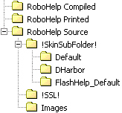
As you can see, there are three top-level folders.
- RoboHelp Compiled - Contains compiled WebHelp files. This folder will be empty.
- RoboHelp Printed - Contains generated Word and PDF files. This folder will be empty.
- RoboHelp Source - Contains all the files RoboHelp needs to manage your document.
This structure allows you to create more folders within the master project folder as necessary. For example, the Fusion Server Software Development Kit has folders for document reviews, Java source code, and support files such as Excel worksheets. The Smart Client Scripting User Guide has folders for Builder consoles, document reviews, Java source code, and support files such as Visio drawings.
All the files RoboHelp needs to manage your project can be found in the RoboHelp Source folder. This folder contains three subfolders.
- !SkinSubFolder! - A skin gives your WebHelp a unique look. Within this folder are three subfolders. Two of those folders - Default and Flashhelp_Default - are standard skins provided by RoboHelp. We always use the DHarbor skin, which was created especially for us. As you will see, the WebHelp template uses this skin. RoboHelp manages the contents of this folder, so you should never have to work with this folder.
- !SSL! - This is the default folder within which your compiled help and printed documents would be located. RoboHelp also manages the contents of this folder, so you should never have to work with this folder. However, we recommend that you store your compiled help files within the RoboHelp Compiled folder and your printed documents within RoboHelp Printed folder.
- Images - The images referenced by the RoboHelp project template are stored within this folder. We recommend that you place all your images within this folder to facilitate image management.
Now, let's take a look at what we have included in the project template.
1 | HTML Files  The following topics are all conditionally tagged as Not_Help so they will never appear in your WebHelp or printed documents.  - AA_Note - Three pairs of Note, Tip, and Warning tables are provided. One table from each pair is sized for our standard printed page width of 5.5 inches. The other table is sized to appear in a Step-Action table and has a width of 4.5 inches.  - AA_Table - Two types of preformatted Step-Action tables are provided, one with a Result and one without. Preformatted tables are also provided for Java and JavaScript code samples as well as sample output.
2 | Images  - Note.gif  - ocean_arrow_sm.gif  - ocean_bullet_sm.gif  - smallbabyblue.jpg  - Tip.gif  - Warning.gif
3 | Style Sheets  - DH_Styles.css - To ensure a consistent appearance of our online help, all our technical documentation projects use this cascading style sheet (CSS).
4 | Templates  - DHarbor.htt - When you create a new topic, this template will be used.
5 | Skins  - DHarbor - To ensure a consistent look-and-feel of our online help, our technical documentation projects use this specially designed skin.
6 | Conditional Build Tags  - Comment - You can use this tag to include messages to yourself or as a placeholder for missing content. For example, you can include a comment to remind yourself to verify information or to indicate missing information.  - Not_Help - Topics and content that are not part of online help or printed document should be marked with this conditional tag. For example, AA_Note and AA_Table are marked with this tag. Topics and content marked with this tag will not appear in WebHelp or printed documents.  - Online - Use this tag if the topic or content is specifically intended for WebHelp.  - Print - Use this tag if the topic or content is specifically intended for printed documents.
7 | Single Source Layouts  - WebHelp Template (see Creating an Online Help Layout for more information) - This template is configured to produce online help in WebHelp format.  - Printed Template (see Preparing a Printed Document for more information) - This template is configured to produce a printed document in Microsoft Word format.

Documentation Conventions
The following table summarizes the standard document formatting conventions. Additional details are provided in subsequent sections.
Item | Convention | Example
Book references | Title caps; italic | See PiiE Smart Client Builder User Guide for more information
Button names | Bold; capitalization follows interface | Click Apply
Chapter references | Title caps | See Chapter 9, Extending Forms, for more information.
Code samples within text and as separate paragraphs | Monospace | the pointer psz
Dialog box title | Bold; capitalization follows interface | The Ontology Query Behavior dialog box opens.
Error message names | Bold; capitalization follows interface | If the JAR creation process fails, then a Cannot Create Deployable JAR File error will appear.
File extensions | Monospace; all lowercase; prefix with . | .mdb  .doc
File names | Monospace; use exact spelling as stored | testProject.haml
File types | Monospace;all caps | The information is stored in a HAML file.
Folders and directories | Monospace; use exact spelling as stored | <ED_Install_Dir>\logs
Icon names | Bold; title caps | To create a new process, click the New icon on the toolbar.
Key names, key combinations, and key sequences | All uppercase; follow spelling on key; use + for key combinations and , for key sequences | ALT, CTRL (key names)  CTRL+X (key combination)  SHIFT, F7 (key sequence)
Labels | Regular; capitalization follows interface | Select the Find Entire Cells Only option
Menu names, options and commands | Bold; capitalization follows interface; when using pipe character (|) do not leave space between menu names and commands. | Select File|New From
Operators | Monospace | +, -
Replacement text | Title caps; same style as replaced text; angle brackets (<>) around text; underscore between words | C:\Program Files\  <PSC_Install_Dir>  \Smart Client\
Section references | Title caps; in quotation marks; include chapter reference if in a different chapter | See "Using Fonts" earlier in this chapter.  See "Using Fonts" in Chapter 12, Working with Text.
Tab names | Bold; capitalization follows interface | Click the Processes tab
Toolbar button names | Bold; title caps | New button
URLs | monospace; lowercase; break before forward slash; no hyphenation | http://www.dharbor.com  http://www.mysite.com  /search/index.html
Windows, named | Bold; capitalization follows interface | Builder window
Windows, unnamed | Regular; lowercase | document window  popup window

Menus
Menus contain commands or selectable options.
Use choose or select when referring to selecting or choosing menu commands.
From the File menu, choose Open.
Select File|Open.
From the Format menu's Reorder submenu, select To Back.
Select Format|Reorder|To Back.
It is recommended that whenever possible, you use the more compact form.
Use context menu to refer to any menu that appears when you right-click an object.
If a menu item is a check box or radio button, append the word option to the menu item.
From the Edit|Advanced Options menu, select the Check Spelling option.

Dialog Boxes
The following table describes the common dialog box elements you will encounter.
UI Element | Convention | Example
Check box | Use select for setting the checkmark and clear for removing the checkmark | Select the Group By option.  Clear the Case Sensitive option.
Button | Avoid including the term button unless required for clarity; for buttons represented by small icons, use the icon whenever possible. | Click Query.  To import a model, click .
Combo box | Use drop-down list | Select a font size from the Size drop-down list.
Drop-down arrow | Arrow next to drop-down lists; use the arrow icon when appropriate. | Click the Size arrow to see more options.  To see more options, click in the Size drop-down list.
Drop-down list box | Use drop-down list | Select a state from the State drop-down list.
Edit box | Use field. Use type (preferred) or enter when instructing the user to supply information. | Type your user name in the Username field.  Enter the URL into the Data Source field.
Group box | Frame that encloses a set of related options. Use <GroupBoxTitle> area. | In the Options area, select the Case Sensitive option.
Label | Use to reference unnamed UI element, such as an edit box or drop-down list. | Type the text you want to locate in the Find field.
List box | Use list. | Select a zip code from the Zip code list.
Radio button | Use option. | Select the On option.
Slider | Use slider. | Move the Volume slider to the right to increase the volume.
Spin box | Use field. | In the Time area, type or select the starting time from the Start field.
Text box | Use field | Type a description in the Description field.

Code Formatting
Programming elements embedded within Body Text or Table paragraph styles are formatted using the CodeText character style.
For sample code on its own line or lines within body text, use the Code paragraph style.
import com.eidea.bizmarc.util.bof.BizManager;
import com.eidea.bizmarc.util.bof.BizObject;

import com.eidea.util.structure.NameValue;
For sample code on its own line or lines within a table, use the Code paragraph style.
1 | public class SDKLogin {
2 | public static void main(String[] args) {
3 | if(args.length != 2) {
4 | System.out.println(
5 | "Parameters: username password");
6 | System.exit(0);
7 | }
8 | if(!BizManager.login(args[0], args[1]))
9 | return;
10 | }
11 | }
The method name in a method signature should be in CodeBold. Method parameters should be in CodeItalic.
public static boolean login(
String username, String password)

Enterprise Designer Naming Conventions
Enterprise Designer's main application window is shown in the following figure. Selected UI elements have been called out.
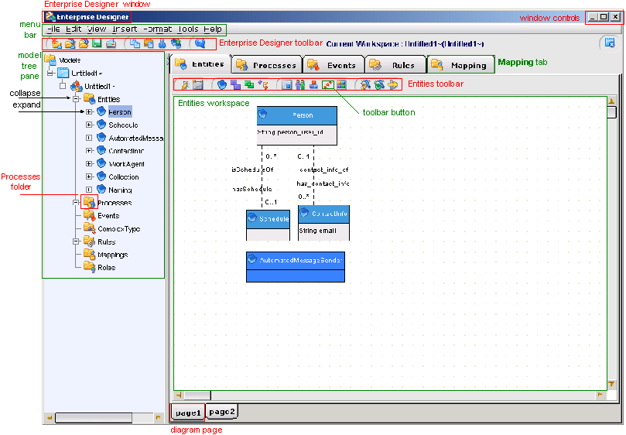
A sample dialog box from Enterprise Designer is shown in the following figure. Typical naming and formatting conventions used on dialog boxes are called out in the figure.
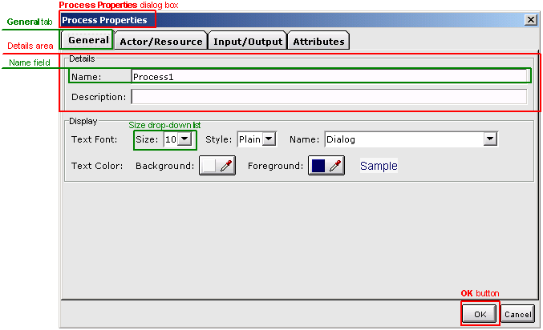

Fusion Administrator Console Naming Conventions
The Fusion Server Administration Console's main application window is shown in the following figure. Selected UI elements have been called out.
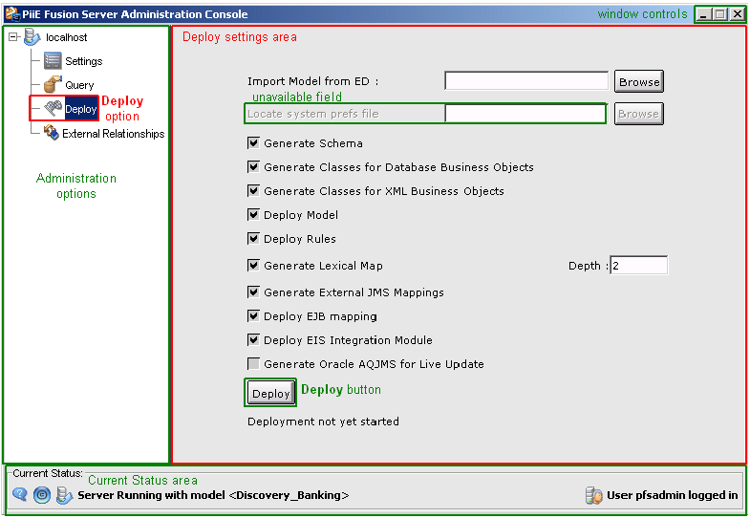

Smart Client Administrator Console Naming Conventions
The Smart Client Administration Console's main application window is shown in the following figure. Selected UI elements have been called out.
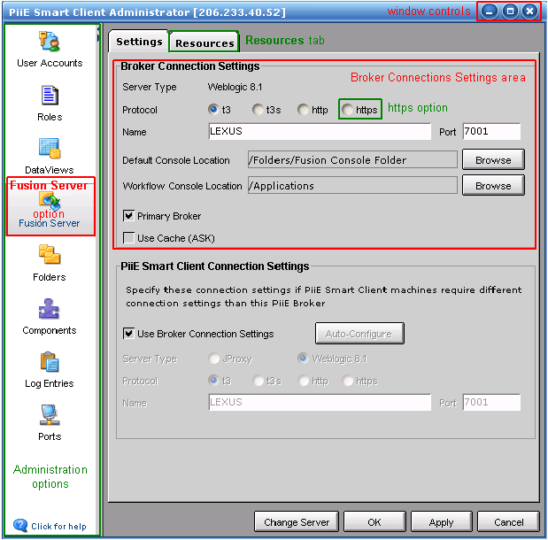
A sample dialog box from the Smart Client Administrator Console is shown in the following figure.
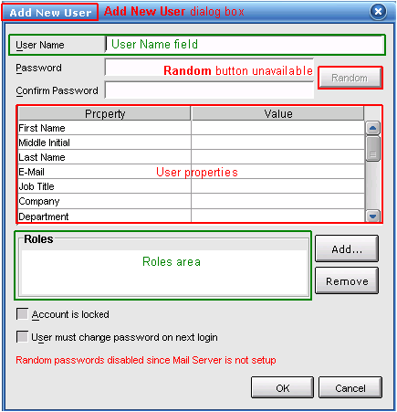

Smart Client Builder Naming Conventions
The Smart Client Builder's main application window is shown in the following figure. Selected UI elements have been called out.
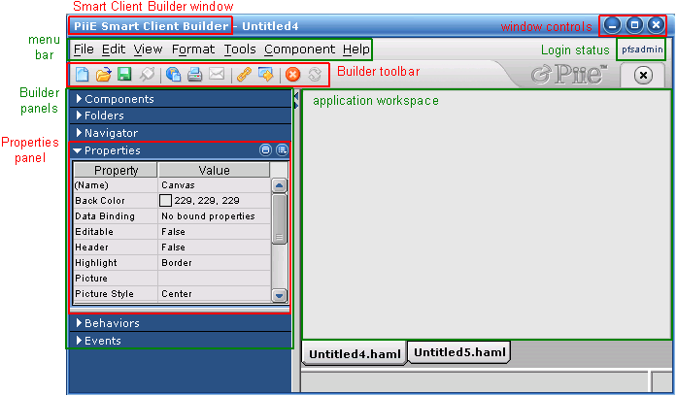
A sample dialog box from Smart Client Builder is shown in the following figure.
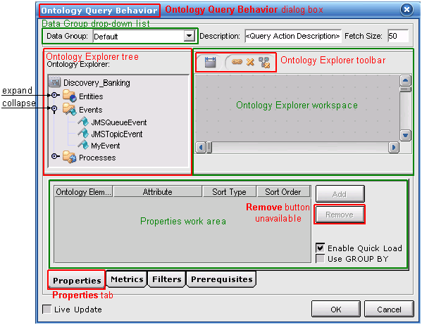

Additional Conventions

Topic Length
There is no minimum or maximum length for an online help topic. Ideally, the content (exclusive of See Also links and expanding or drop-down hot spots) should be no more than two display pages.

Chapter Length
There is no minimum or maximum length for a chapter. However, chapters should revolve around tightly focused topics or features.
If a chapter exceeds 20 to 25 pages, then you should consider further subdividing the content, if possible.
For example, Enterprise Designer's Entities tab allows you to create and define basic entities, virtual entities, complex types, and work agents. That tab also provides access to dialog boxes that allow you to define an entity's attributes, synonyms, annotations, and default console.
A single chapter could describe the Entities workspace and provide procedures for creating all four of these concept types. But the chapter would be excessively long.
Breaking the content of the Entities tab into smaller, more manageable "chunks" makes it easier for the user to understand and absorb critical information. An introductory chapter discusses entities on a general level and describes the workspace. Subsequent chapters extend that discussion to basic entities, virtual entities, complex types and work agents.

Images
Our documentation will be created on computers running a variety of Windows operating systems, such as Windows 2000 and Windows XP. Two different Windows platforms may have a different look-and-feel.
PiiE Windows installations are targeted for the Windows 2000 operating system. Consequently, any product-related images, such as dialog boxes and messages, should be taken using that operating system's window style, Windows Classic.
If your computer is running Windows XP, you can reconfigure the display to Windows Classic using the following procedure.
1 | Select an empty area of your display, right-click and select Properties from the context menu.  Result: The Display Properties dialog box opens.
2 | Click the Themes tab and select Windows Classic from the Theme drop-down list.  Result: The Sample area illustrates how that theme will appear.
3 | Click OK.  Result: The display changes to reflect the new theme.

Online Help

Creating an Online Help Layout
To define a new WebHelp layout, complete the following steps.
1 | Expand Single Source Layouts , right-click the WebHelp Template and select Duplicate Layout.  Result: The New Layout dialog box opens.
2 | Enter a new Layout Name.  Click OK.  Result: The new layout appears in Single Source Layouts.
3 | To modify that layout, right-click it and select Properties.  Result: The WebHelp wizard's General page appears as shown below.  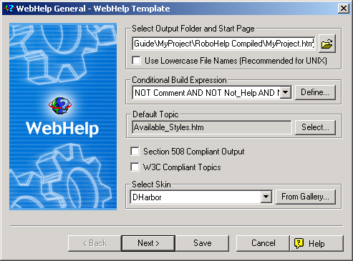
4 | The WebHelp files will be stored in the RoboHelp Compiled folder. The default start page is simply <ProjectName>.html where <ProjectName> is the name name you assigned to your project when you created it.  The conditional build expression excludes topics and content marked with the Comment, Not_Help, and Print tags. If you have defined other conditional build tags, you can modify the conditional build expression by clicking .  The default topic will be the first topic displayed when a user accesses WebHelp. To define a different default topic click .  Finally, note that the selected skin is DHarbor.  When you are done click .  Result: The WebHelp wizard's Navigation page appears as shown below.  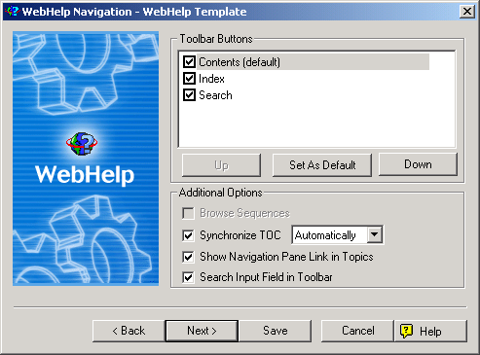
5 | Do not change any of these settings.  Click .  Result: The WebHelp wizard's Options page appears as shown below.  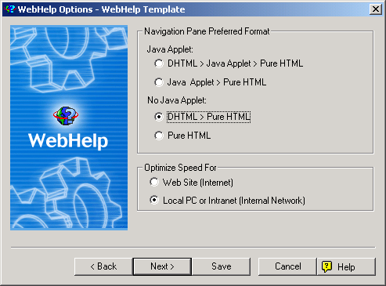
6 | Because our users will access online help from their own PCs or through a local intranet, we want to optimize speed for a local PC.  Click .  Result: The WebHelp wizard's Publish page appears as shown below.  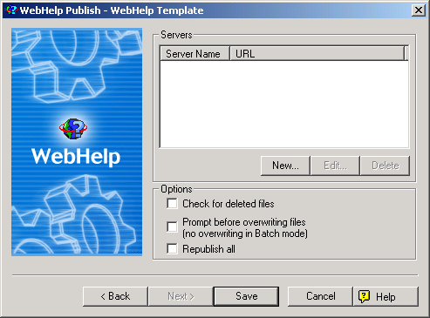
7 | Because you will not be publishing your WebHelp to a server, this page can be left blank.  Click .  Result: The WebHelp wizard closes.

Generating Online Help
To generate and view your online help, complete the following steps.
1 | Expand Single Source Layouts , right-click the desired WebHelp layout, and select Generate from the context menu.  Result: The WebHelp wizard's General page appears.
2 | You can modify any of the WebHelp configuration settings.  When you are done, click .  Result: Your help topics are compiled and placed into the folder you specified. When the compilation completes, the following message appears.  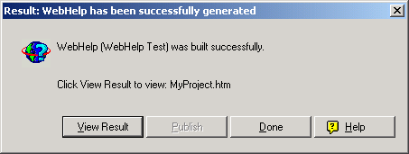

Preparing a Printed Document
Preparing a printed document is a three-step process.
- Create a printed document layout
- Generate the printed document
- Clean up the printed document

Creating a Printed Document Layout
The RoboHelp project template contains a single source layout called Printed Template. To customize that template for your document, complete the following steps.
1 | To make a copy of Printed Template (or any existing printed template), right-click it and select Duplicate Layout from the context menu.  Result: The New Layout dialog box opens.
2 | Type a new name in the Layout Name field and then click OK.  Result: The new layout appears under the Single Source Layouts folder.
3 | Right-click the new layout and select Properties from the context menu.  Result: The Print Document wizard launches and the General page displays as shown below.  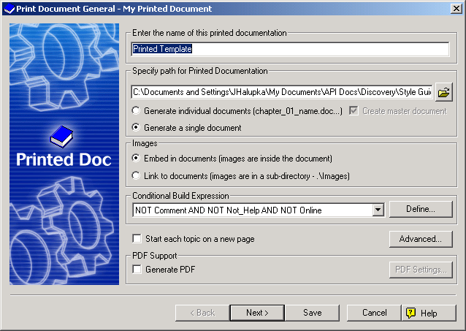
4 | Print Document General  Change the name of the document. This will be the name that appears on the cover and title pages.  Under Specify path for Printed Documentation, you can accept the default path, which is  <ProjectRoot>\RoboHelp Source\!SSL!\  <TemplateName>\<DocumentName>.doc  OR  you can click and navigate to another folder. It is recommended that you store your printed documentation in the following location  <ProjectRoot>\RoboHelp Printed\  <TemplateName>\<DocumentName>.doc  where  <ProjectRoot> is the path to the RoboHelp project  <TemplateName> is the name of the single source layout template  <DocumentName> is the name of the document  We recommend that you generate your printed output as a single document, if possible.  In the Images area, select Embed in document.  A default conditional build expression has been defined for you. Unless you created more conditional tags, you should leave this expression alone.  Clear the Start each topic on a new page option.  Clear the Generate PDF option.  Click Next.  Result: The Content page appears as shown below.  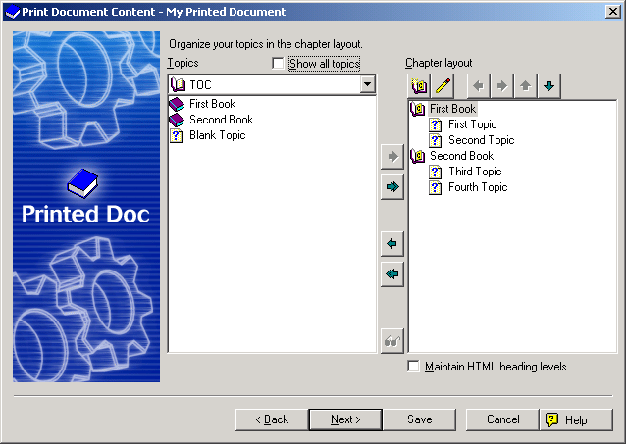
5 | Print Document Content  Select which books and topics you want to include in your printed output.  You can also customize your chapter layout by creating new books and selecting which topics you want to include in those books.  When you are done, click Next.  Result: The Section Layout page appears as shown below.  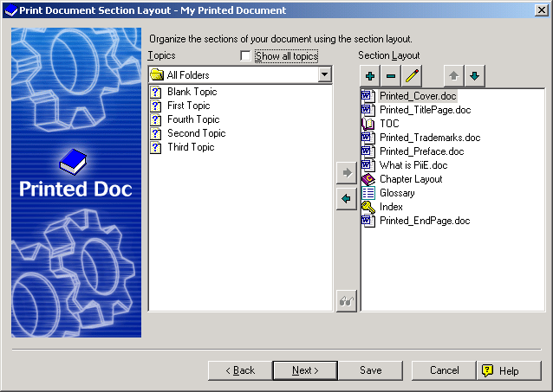
6 | Print Document Section Layout  The Section Layout list in the previous figure shows the default layout of a complete end-user document.  This layout contains the following word documents:  - Printed_Cover.doc - Template for the cover page of your document.  - Printed_TitlePage.doc - Template for your document's title page and a disclaimer.  - Printed_Trademarks.doc - Standardized list of product and corporate trademarks used in our products or referenced in our documentation.  - Printed_Preface.doc - Template that contains placeholders for information specific to your document, such as its purpose, intended audience, and contents.  - What is PiiE.doc - A standardized introductory chapter included in every end-user document.  - Printed_EndPage.doc - Standardized back cover for all end-user documents.  See the appendixes for the structure and content of these standardized documents.  If you are printing an excerpt from your document, such as a set of chapters to be reviewed, then you do not have to include all this boilerplate.  The Glossary is a standardized set of defined terms and acronyms used throughout our end-user documents. The glossary will be updated periodically.  When you have completed your section layout, click Next.  Result: The Appearance page appears as shown below.  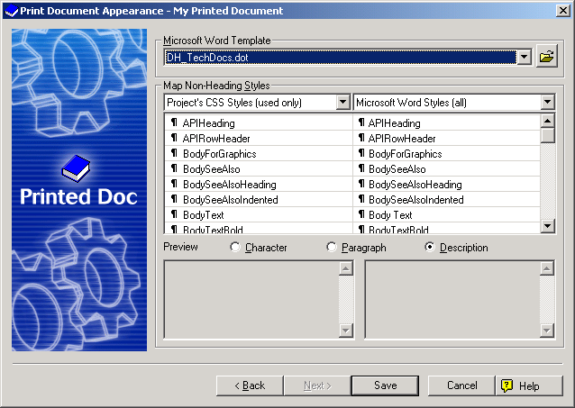
7 | Print Document Appearance  The RoboHelp project template includes a default Microsoft Word template. Because all our end-user documents are based on this template, you must not change it.  The RoboHelp project's styles have already been mapped to corresponding Microsoft Word template styles.  New styles should only be added when absolutely necessary. A procedure is in place for integrating new styles into our RoboHelp style sheet as well as into our Word document templates. See Defining New Styles for more information.  Click Save.  Result: The Print Document wizard closes.

Generating a Printed Document
To generate and view your printed document, complete the following steps.
1 | Expand Single Source Layouts , right-click the desired printed document layout, and select Generate from the context menu.  Result: The WebHelp wizard's General page appears.
2 | You can modify any of the WebHelp configuration settings.  When you are done, click .  Result: Your document is generated and placed into the folder you specified. When the document is complete, the following message appears.  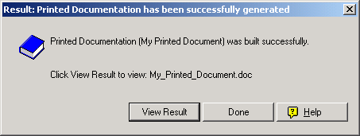

Cleaning Up a Word Document
The level of effort required to clean up your Word document depends on many factors, such as the specific version of Microsoft Word you are using. Each technical writer encounters a unique set of problems that have to be addressed after generating a Word document, even though the same RoboHelp style sheet and Word document template were used.
This section is intended to address a variety of problems that you may encounter. You may or may not encounter a particular problem, but if you do, and it happens to be documented in this section, then you will learn how to correct it.
If you encounter a problem that has not been documented in this section, you should ensure that the problem and its solution are captured so it can be added to a subsequent version.
During cleanup, we recommend at least four passes through your document.
- First pass - Clean up headers, footers, page numbering, and the like.
- Second pass - Repair standard styles and replace non-standard styles with standard styles.
- Third pass - Clean up content, especially tables.
- Fourth pass - Update and paginate the table of contents and the index, if you have one.

First Pass
The first pass is intended to clean up headers, footers, chapter titles, and the like. Don't worry about style issues, content flow, table structure, and other lower level details.
You may encounter any of the following situations. If so, simply follow the associated instructions to correct them.
1 | Problem: Change "Table of Contents" to "Contents."  Solution: Double-click the Contents' Odd Page Header and change "Table of Contents" to "Contents."
2 | Problem: "Chapter n", where n is a chapter number, appears before "Preface" and "Trademarks."  Solution: Select and delete "Chapter n" from "Preface" and "Trademarks."
  "What is PiiE" should now be Chapter 1.
3 | Problem: Page numbers in "What is PiiE" are roman numerals and do not begin with 1.  Solution: Double-click Chapter 1's footer and click Format Page Number (). Select 1, 2, 3 from the Number Format drop-down list. In the Page Numbering area select Start At. 1 should appear in the edit box. Click OK.
4 | Problem: Page numbering in Chapter 2 starts with 1.  Solution: Double-click Chapter 2's footer, and click Format Page Number. In the Page Numbering area, select Continue from previous section. Click OK.
5 | Problem: There is no space between a chapter number and its title.  Solution: For each such chapter, move the cursor between the chapter number and the first letter in the chapter title. Press SHIFT+ENTER.
6 | Problem: The Glossary and Index have chapter numbers.  Solution: Select and delete Chapter n from Glossary and Index.
7 | Problem: The Index title and the index itself are on separate pages  Solution: Place the pointer at the end of the Index title and press DELETE.
8 | Problem: Index does not appear in the header on the Index's third page.  Solution: Double-click the header to open the Header and Footer tool. If Same as Previous appears on the right side of the header, then click Same As Previous to remove it. Replace the header text with Index.
9 | Problem: The page immediately following the index contains Chapter n, where n is a number.  Solution: Select the chapter and press DELETE twice.
10 | Problem: The two pages that comprise the back cover have non-blank headers and footers.  Solution: To remove the headers and footers, complete the following steps.
  Because a new section begins on an odd numbered page and we want the back cover to appear on an even numbered page, the first page of the back cover will be blank. The back cover will also have headers and footers that reflect those of the remaining chapters.
  a | Double-click the first page header.  Result: The first page header displays and the Header and Footer tool opens.
  b | If Same as Previous appears on the header's right side, then click Same As Previous () to remove it.
  c | Click Show Next to display the even page header.  If Same as Previous appears on the header's right side, then click Same As Previous to remove it.  If the document name appears on the header's left side, remove it.
  d | Click Switch Between Header and Footer.  Result: The even page footer displays.
  e | If Same as Previous appears on the footer's right side, then click Same As Previous () to remove it.  If the page number appears on the footer's left side, remove it.
  f | Click Show Previous to display the first page footer.  If Same as Previous appears on the footer's right side, then click Same As Previous () to remove it.  If the page number appears on the footer's right side, remove it.
11 | Problem: An extra page follows the back cover's address information.  Solution: Position the cursor at the end of the address information, that is after www.dharbor.com, and press DELETE.

Second Pass
Fix styles that did not convert correctly from RoboHelp to Microsoft Word. A style can be "broken" in one of two ways:
- The style embedded in the document was not properly copied from the document template.
- The style was not correctly applied in the document.
In either case, the follow steps should correct any errors to a style.
1 | Select Format|Styles.  Result: The Styles and Formatting tool opens.
2 | Move the pointer to a line in your document containing an incorrectly displayed style.  Result: That style will appear in the Pick Formatting to Apply list.
3 | Move the pointer over that style in the list, click , and choose Select All Instances from the menu.  Result: Every occurrence of that style will be selected.
4 | If the style is correct in the Styles and Formatting area, simply click on the style.  If the style is not correct, then click , and choose Modify from the menu. Change the properties of the style as needed. When you have finished, click OK.  Result: Every selected occurrence of that style will be changed.
In the second phase of this pass, you should step through all the styles used in your document.
A Show drop-down list appears at the bottom of the Styles and Formatting area. Select Formatting in Use.
Scroll through the Select formatting to apply list, looking for styles that are not part of the Microsoft Word document template, DH_TechDocs.dot. In many cases, these styles will be similar to styles that are in that template but have additional formatting applied to them, such as space above or below, a different font, and the like.
For a given non-standard style, if a standard style can be applied to it, perform the following steps.
1 | Move the pointer over the non-standard style, click , and choose Select All Instances from the menu.  Result: All occurrences of that non-standard style are selected in the document.
2 | Click on the standard style that you want to use in place of the non-standard style.  Result: All occurrences of that non-standard style are replace with the specified standard style.

Third Pass
During the third pass, scroll through your document and correct any layout problems you encounter. To get a better idea of your document's visual layout, display an entire page on the screen.
You may have to perform this step several times to ensure your layout and content are the way your want it to appear.
The following table contains a number of problems that have appeared in previous documents.
 |  | Whenever you make a change to your Word document, you should also make the identical change to the associated RoboHelp topic if appropriate. For example, if you correct misnumbered steps in your Word document, then you should make the same correction to the corresponding topic in your RoboHelp project. However, if you make a stylistic change, such as specifying a header row, then you do not have to make any changes to the corresponding topic in your RoboHelp project.
# | Description |  | Edit  Project?
1 | Problem: Image too large and is cropped at right edge.  Solution: Adjust image size. |  | Yes
2 | Problem: Image not centered. Incorrect style applied.  Solution: Apply BodyForGraphics style. |  | Yes
3 | Problem: Wrong style applied.  Solution: Replace with correct style. |  | Yes
4 | Problem: Table with header row breaks across page.  Solution: Select header row. Select Table|Table Properties. Click Row tab and select Repeat as header row at top of each page. |  | No
5 | Problem: Row breaks across page and you want to keep that rows on same page.  Solution: Place pointer inside table. Select Table|Table Properties. Click Row tab and clear Allow row to break across page. |  | No
6 | Problem: Table row header is orphaned at bottom of page.  Solution: Place pointer in first column of header. Select Format|Paragraph. Click Line and Page Breaks tab and select Page break before. |  | No
7 | Problem: Header orphaned at bottom of page.  Solution: Place pointer in header. Select Format|Paragraph. Click Line and Page Breaks tab and select Page break before. |  | No
8 | Problem: Table not centered on page or in table.  Solution: Place cursor in table. Select Table|Table Properties. Click Table tab and select Center in the Alignment area. |  | No
9 | Problem: Steps incorrectly numbered.  Solution: Renumber steps. |  | Yes
10 | Problem: Column label wraps to new line in middle of word.  Solution: Adjust table's column widths. |  | Yes
11 | Problem: One or more extra lines appear between the end of a section and the beginning of the next section. This may occur if a table or note appears at the end of a section.  Solution: Remove the extra line(s). |  | Yes
12 | Problem: Code examples have too much space between lines.  Solution: Select the table. Select Table|Table Properties. Click the Cell tab, then Options. in the Cell margins area, set Top and Bottom to 0". |  | No
13 | Problem: Note, Tip Warning or other images are free to float. When you select the image, the following frame appears around it:    Solution: Select the image. Select Format|Picture. Click the Layout tab and, in the Wrapping style area, select In line with text. |  | No
  Floating images can cause spacing problems between the image and the following paragraph or header. It can also cause pagination problems in which unexpected page breaks occur.
14 | Problem: A numbered list does not start at 1.  Solution: Select the first item, right-click and select Restart Numbering from the popup menu. |  | No

Fourth Pass
In the fourth and final pass, you will clean up your table of contents and index. These items are dealt with last because the document's pagination could change during any of the previous passes. In fact, it is quite likely that this will be the case.
To update the table of contents, move the cursor to any line in that table, right-click and select Update field.
If you have not changed or reorganized the content, especially headers, then select Update page numbers only in the Update Table of Contents dialog box. If you have change or reorganized the content, then select Update entire table in the Update Table of Contents dialog box.
To update the index, complete the following steps.
1 | Move the pointer to any entry in the index. Right-click and select Update Field.
2 | Scroll through the index and eliminate duplicate entries, such as that shown in the following figures.  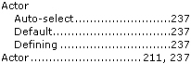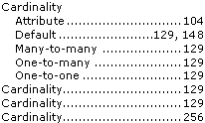  Note that Actor appears twice and Cardinality appears four times with two of those entries having the same page number. Merge duplicate entries and eliminate duplicate page numbers so they appear as illustrated in the following figures.  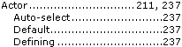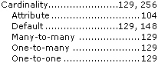
3 | Some index entries' page references may wrap onto multiple lines. In other cases there may be little or no spacing between an index entry and its page references. Examples of these situations are shown in the following figures.  When you encounter situations like this, place the cursor after the last character in the index entry and press SHIFT+ENTER to wrap the page references to a new line as shown in the following figures.
4 | The space above and below each index entry should be 0pt. If it is not, then perform the following steps to change the spacing.  Repeat for each index style that is incorrectly formatted.
  a | Select Format|Styles and Formatting.  Result: The Formatting and Style tool opens.
  b | Place the pointer in one of the index entries whose spacing you want to change.  In the Styles and Formatting tool, the style of the selected text will appear in the Formatting of selected text drop-down list.  Click and select Select All Instance(s) from the menu.  Result: All the occurrences of that style are selected.
  c | Click and select Modify from the menu.  Result: The Modify Style dialog box opens.
  d | Select Format|Paragraph.  Result: The Paragraph dialog box opens.
  e | In the Spacing area, change the Before and After edit boxes to 0".  Result: The Paragraph dialog box closes.
  f | Click OK.  Result: The Modify Style dialog box closes and the changes are made to the document.

Preparing a PDF
Preparing an Adobe Acrobat PDF file is easy once you have the necessary global template and add-in installed and configured.
Before you generate a PDF from a Word document for the first time, you have to perform the following steps:
- Install Acrobat templates and add-ins
- Configure Acrobat conversion settings
You only have to perform these two steps once, the first time you convert a RoboHelp-created Word document to PDF.

Installing Acrobat Templates and Add-Ins
In order to generate an Adobe Acrobat PDF file from a Microsoft Word document, you must ensure that the appropriate global template and add-in have been loaded.
If Acrobat appears on your menu bar, then the necessary global template and add-in is available.
If Acrobat does not appear on your menu bar, then perform the following steps to add them.
1 | Select Tools|Templates and Add-ins.  Result: The Templates and Add-ins dialog box opens.
2 | In the Global templates and add-ins area, look for PDFMaker.dot and RoboHook.wll.  If they are present, select them and then click OK.  Result: Acrobat will appear on your menu bar.
3 | If they are not present, then click Add.  Result: The Add Template dialog box opens.
4 | Navigate to the folder containing PDFMaker.dot, select that file, and then click OK. This file is located within your Adobe Acrobat installation folder, for example  C:\Program Files\Adobe\Acrobat 5.0\  PDFMaker\Office2000  Result: This file will appear in the Global templates and Add-ins list.
5 | Repeat the above procedure for RoboHook.wll. This file is located within your RoboHelp installation folder, for example  C:\Program Files\RoboHelp Office\  RoboHELP\Startup  Result: This file will also appear in the Global templates and Add-ins list.
6 | Make sure both files are selected and then click OK.  Result: Acrobat will appear on your menu bar.

Configuring Acrobat Conversion Settings
If you have not already done so, configure the Adobe Acrobat conversion settings.
1 | Click Acrobat|Change Conversion Settings.  Result: The Acrobat PDFMaker 5.0 for Microsoft Office dialog box opens.  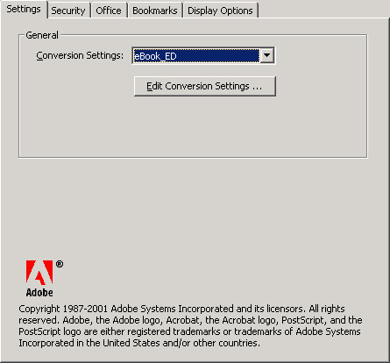
2 | Click Edit Conversion Settings.  Configure the General tab so it looks like the following figure.  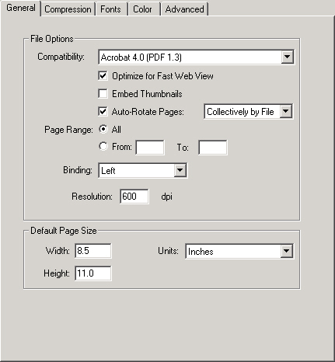  You could change Compatibility to a later version of Adobe Acrobat, such as version 5. But because we want to ensure maximum compatibility with our customers' Adobe Acrobat versions, that is not recommended.
3 | Configure the Compression tab so it looks like the following figure.  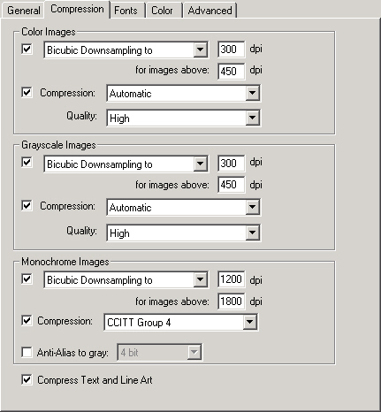  These settings ensure that images, when printed, are clear and crisp.
4 | Configure the Fonts tab so it looks like the following figure.  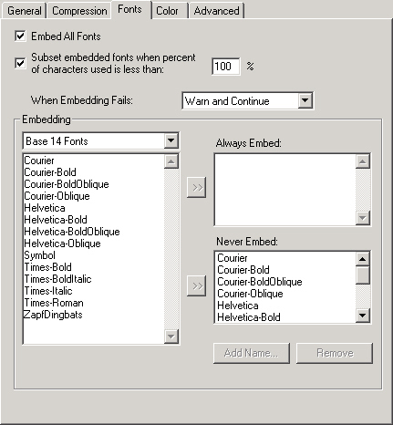  You should not have to make any changes on this tab.
5 | Configure the Color tab so it looks like the following figure.  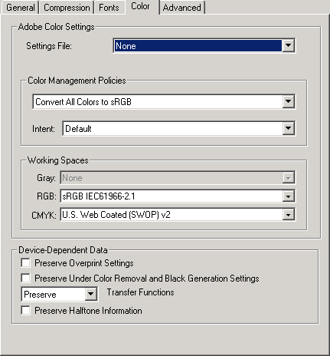
6 | Configure the Advanced tab so it looks like the following figure.  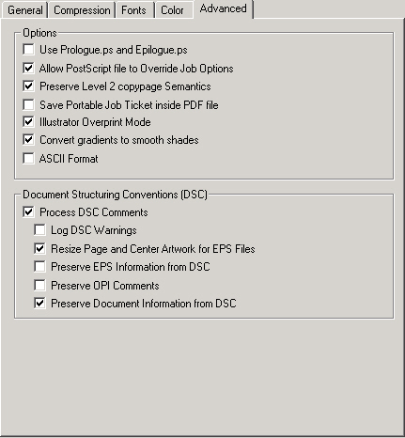
7 | When you have finished editing the conversion settings, click OK.  Alternatively, you can save the modified job options to a new file. To do so, click Save As.  The Save Job Options As dialog box opens. Edit the file name and, optionally, the folder location, and then click Save.
8 | Configure the Office tab so it looks like the following figure.  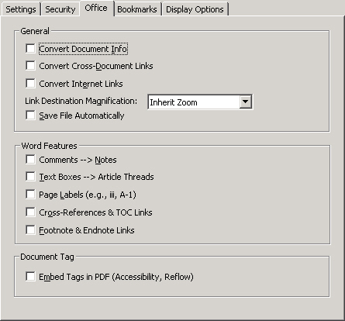  Clearing all these options will significantly increase the speed of the conversion.
9 | Configure the Bookmarks tab so it looks like the following figure.  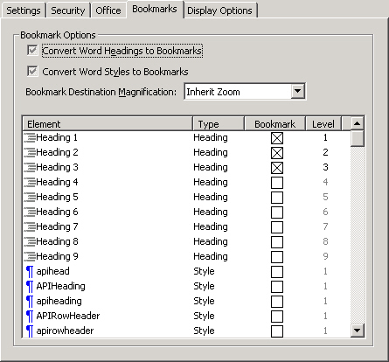  You should not select any bookmark below Heading 3. However, if you used a heading such as APIHeading in your document, then you can include that heading in your list of bookmarks.
10 | Configure the Display Options tab so it looks like the following figure.  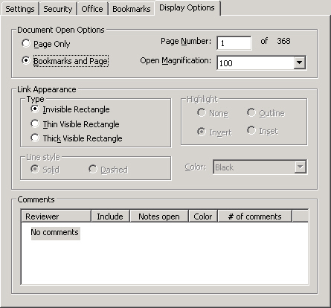  These settings ensure that each of our document's appears in exactly the same way when a user opens a document in Adobe Acrobat.  Bookmarks will appear in a pane on the left side of the window. The document itself will be opened to page 1 at a magnification of 100%.

Creating a PDF
Once your Acrobat conversion settings have been configured, creating the PDF is a snap.
1 | Select Acrobat|Convert to Adobe PDF.  Result: If the Word document has not been saved recently, the following message appears.  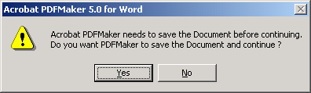
2 | To terminate the creation process, click No.  To continue, click Yes.  Result: The Save PDF File As dialog box opens.
3 | Navigate to the folder where you want to store your PDF file and, if you want, edit the name. Click Save.  Result: The Save PDF File As dialog box closes and a progress dialog box opens.  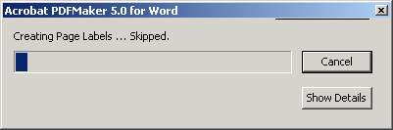
4 | If you want to see additional details, click Show Details.  Result: The dialog box expands to include a details text area.  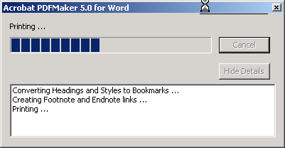
5 | If you want to cancel this operation, click Cancel.  Result: A confirmation dialog opens as shown in the following figure.  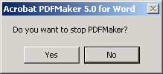  Click Yes to cancel and No to continue creating the PDF.
6 | When your PDF has been created the progress dialog box closes.

Cleaning up a PDF
After you have created your PDF, you might have some cleanup to perform. However that should be minimal.
This process involves the following steps:
- Remove unnecessary functionality
- Adjust bookmark mapping
- Edit bookmarks
The following procedures assume you can edit your PDF in Adobe Acrobat.

Removing Unnecessary Functionality
1 | Open your document in Adobe Acrobat. Select Tools|PDF Consultant|Detect and Remove.  Result: The Detect and Remove dialog box opens.
2 | Configure the dialog box as shown in the following figure.  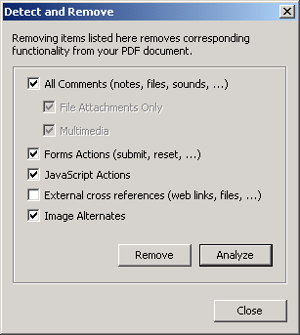  Click Remove.  Result: Acrobat analyzes and removes the specified functionality. When the process completes, a Warnings and Errors dialog box summarizing the process displays.  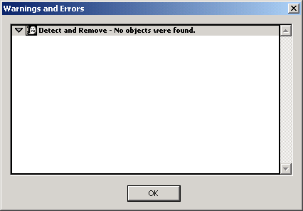
3 | Click to save the file.

Adjusting Bookmark Mapping
1 | For each bookmark, click the bookmark and verify that the document jumps to the chapter or section heading that corresponds to that bookmark.
2 | If the bookmark is set incorrectly, scroll the document so it is properly aligned with the bookmark.  Right-click the bookmark and select Set Destination.  Result: The following warning message appears.  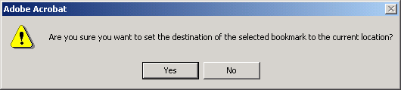
3 | Click Yes if you want to set the destination and No otherwise.
When you have finished, click to save the file.

Editing Bookmarks
Extraneous characters may occasionally appear in a bookmark. The following figure illustrates this.
To correct these occurrences, simply replace or edit the bookmark.
When you have finished, click to save the file.

Checking a Document into CVS
The procedure for checking a document into CVS depends on whether or not the document is new.

Checking a New Document into CVS
1 | Copy your PDF to the following CVS folder.  <CVS_Root>\TechDocs\PDF  where <CVS_Root> is the home folder you specified when you installed CVS.
2 | Start CVS and navigate to <CVS_Root>\TechDocs\PDF.  Because this is a new document, an unknown icon () appears to the left of the file.  In order to check in a new file, you must add it to the repository.  To do this, select the file and click the add selected binary icon (). Result: The unknown icon () changes to a committable icon ().
3 | To commit the file, select it and then click Commit ().  Result: The Commit settings dialog box opens, as shown in the following figure.  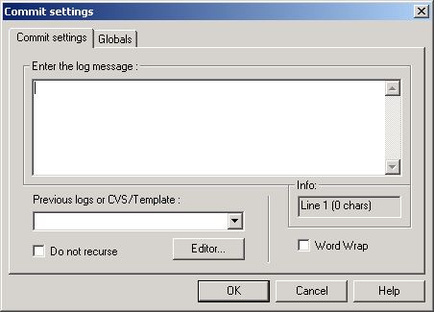
4 | Enter an appropriate log message and then click OK.  Result: The output window displays the progress of the operation. When the file has been checked in, the committable icon () changes to a committed icon ().

Checking an Existing Document into CVS
To check an existing document into CVS, perform the following steps.
1 | Copy your PDF to the following CVS folder.  <CVS_Root>\TechDocs\PDF  where <CVS_Root> is the home folder you specified when you installed CVS.
2 | Start CVS and navigate to <CVS_Root>\TechDocs\PDF.  Because this is an existing document, a committable icon () appears to the left of the file.  To commit the file, select it and then click Commit ().  Result: The Commit settings dialog box opens, as shown in the following figure.
3 | Enter an appropriate log message and then click OK.  Result: The output window displays the progress of the operation. When the file has been checked in, the committable icon () changes to a committed icon ().

Appendix A

Style Templates

Heading Styles
The following tables summarizes the available heading styles and their intended usage. In general, only Heading 1, Heading 2, and Heading 3 will appear in the table of contents.
Style Name | Comment
Heading 1 | Do not use. Style applied by RoboHelp during conversion.
Heading 2 | First-level heading; topic heading style
Heading 3 | Second-level heading
Heading 4 | Third-level heading style; use infrequently
Heading 5 | Avoid.
Heading 6 | Avoid.
Subheading | Convenience heading style that will not appear in table of contents

Paragraph Styles
The following tables summarizes the available paragraph styles and their intended usage.
Style Name | Description
BodyForGraphics | Centers image horizontally on the page
BodySeeAlso | Used for cross-references or cross-reference categories
BodySeeAlsoHeading | Cross-reference heading, generally "See Also"
BodySeeAlsoIndented | Used if BodySeeAlso is used for cross-reference categories
BodyText | Standard paragraph style
BodyTextBold | Convenience style for instances when entire paragraph text must be bold
BodyTextCenter | Centers paragraph horizontally on the page; use for screen shots, dialog box images, etc.
BodyTextIndented | Indents paragraph from both margins; used for long excerpts
BodyTextItalic | Convenience style for rare instances when entire paragraph text must be italic
BulletListItalic | Convenience style for instances when entire list paragraph must be italic
BulletListLevel1 | First level bulleted list
BulletListLevel2 | Second level bulleted list
BulletListLevel3 | Third level bulleted list
BulletListSmall | List with smaller font size; generally used with tables embedded within other tables
Code | Used for method signatures and short code samples
CodeLineNumber | Used for line numbers in code samples; generally will appear in tables
CodeSmall | Smaller code font; generally used with code samples contained in tables embedded within other tables
Normal | Base style. Do not use.
NumberedList | Standard numbered list style
Subheading | Equivalent to Heading 4 but will not appear in table of contents

Table Styles
The following tables summarizes the available heading styles and their intended usage.
Style Name | Description
APIHeading | Column heading style for API tables in SDKs; can appear in table of contents
APIRowHeader | Row heading style for API tables in SDK
Table | Main body style for tables
TableHeader | Table header style
TableButtons | Used for icon and button images
TableIndented | Convenience style for indenting a table paragraph
TableNote | Used for note, tip, and warning images
TableNumber | Used for step-action procedure numbering
TableSmall | Smaller font for use with tables embedded within other tables
TableTitleWhite | Used for cases where first table row background color is not white

Font Styles
The following tables summarizes the available font styles and their intended usage.
Style Name | Usage
Bold | Convenience style
BoldItalic | Convenience style
BoldUnderline | Convenience style
ButtonText | Button and icon names
CodeBold | Method names in method signatures
CodeBoldItalic | Convenience style
CodeItalic | Arguments names in method signatures
CodeText | Short snippets of code within body text or table text
Italic | Convenience style
LabelText | UI element labels
MenuItemText | Menu and menu item names
RevChanges | Convenience style to emphasize changes
TabTitleText | Tab titles
UITitleText | Dialog box, wizards, and other UI titles

Table Templates

Step-Action Tables
1
2
3

1 | Result:
2 | Result:
3 | Result:
4 | Result:

Code Example Table
1
2
3
4
5
6
7
8
9
10
11
12
13
14
15
16
17
18
19
20

Output Table

Note Templates
Two different sizes of note templates have been provided. The first is 5.5", the width of a standard printed page. The second is 4.5" and is intended for use within the actions column of a step-action table.

Digital Harbor, Inc.
1851 Alexander Bell Drive
Suite 200
Reston, VA 20191
www.dharbor.com

