FOR SALE BY OWNER

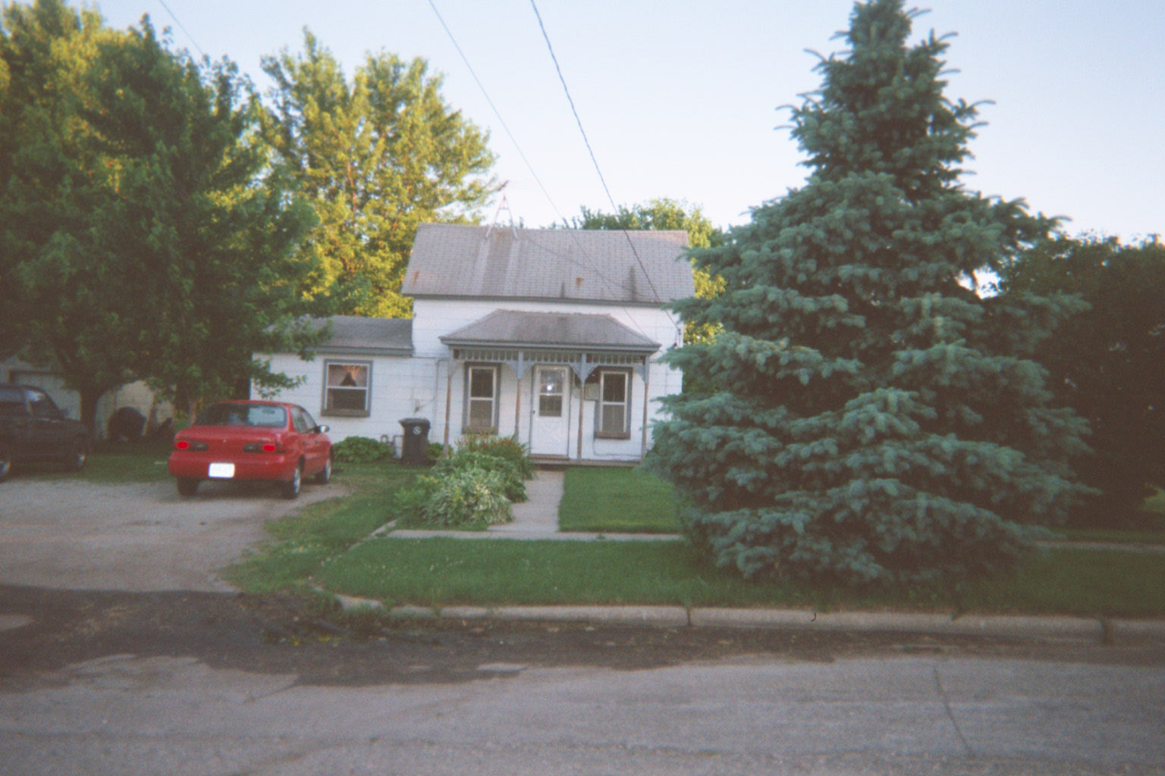 | List Price:  Style:  Ownership:  Year Built:  Total SqFt:  Acres Est:  Bedrooms:  Bathrooms:  Garage Stalls:  Address: | $74,900  1 ½ story  Single Family  1856  1,223  ¾  3  1  4  129 South St.  West Concord, MN 55985

Specifications |  |  |  | Layout | main | upper
SqFt, Main:  A/C:  Heat Type:  Heat Fuel: Avg. Utilities:  Water Sftnr:  Water:  Sewer: | 943  Central  Forced Air  Nat. Gas  $160  Included  City  City | SqFt, Upper:  Garage Type:  Garage SqFt:  Drive Type:  Exterior:  Zoning:  Lot Size Desc:  Legal Desc: | 280  Detached  1092  Crushed rock  Hardboard  R1  Irregular  Lengthy—see owner | Living Rm  Dining Rm  Kitchen  Family Rm  Laundry  Bathroom  Master BR  Bedrooms | 1  1  1  1  1  1  1  1 | 1

Schools | Amenities | Taxes/Fees
Elem: Triton  Middle: Triton  High: Triton | Large lot, Edge of town  Mature trees  Garden already planted  New AC  New Water Heater | Gross Taxes: $804  Tax Year: 2000  Tax Class: Homestead  Assessments: None  Assoc. Fees: None

Included  Stove  Water Softener  Refrigerator (negotiable) | Not Included  Washer  Dryer

Comments
Well-maintained home with neutral décor. Great starter home. Room to add-on. See more information and pictures on the web at http://www.geocities.com/garrettwinn/homeforsale.html

Large ¾ acre lot with mature trees and open field in back and on one side. Two single-car garages and one double-car garage. One of the single-car garages has storage area above and is heated. All three garages have electricity. Garage square footage is approximate. Dog may bark, but is friendly. She likes to jump up on people.

Contact Information  Owner: Garrett and Heidi Winn  Phone: (507) 527-8558  Occupant: Owner | Instructions: Call at least one hour before or schedule appointment anytime. Realtors welcome.

